**Arunachal Pradesh**

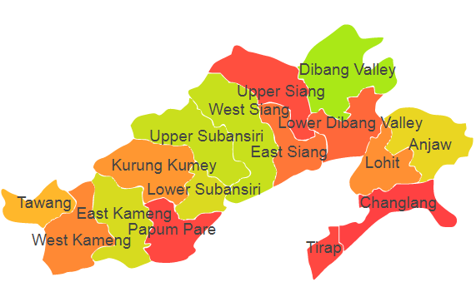

Arunachal Pradesh comprises of two Agro Ecological Regions (AER) namely 16 and 17.

**Agro-Eco Region 16 :** AER 16 in Arunachal Pradesh comprises of Along, Anini, Anjaw, Bomdila, Daporijo, Dibang Valley, East Kameng, East Siang, Khonsa, Kurung Kumey, Lohit, Lower Dibang Valley, Lower Subansiri, Papum-pare, Pasighat, Seppa, Tawang, Tezu,Upper Siang, Upper Subansiri,West Kameng,West Siang and Ziro districts of Eastern Himalayas under Agro Ecological Sub Region (AESR) 16.3.

**Agro-Eco Region 17 :** AER 17 in Arunachal Pradesh comprises of Changlang and Tirap

districts of North-eastern Hills under Agro Ecological Sub Region (AESR) 17.1.

**Major NRM issues :**

**AESR 16.3 :** The region warm to hot perhumid ESR with deep, loamy to clayey Red Loamy soils, low to medium AWC and LGP 300 days in a year.

|  |  |  |  |  |
| --- | --- | --- | --- | --- |
| **Districts** | ***Land degradation*** | ***Soil health & fertility*** | ***Water related constraints*** | ***Environmental constraints*** |
| Along | Acid Soil under water erosion & Acid Soil under open forest | **-** | Mostly Rainfed | **-** |
| Anini | Acid Soil under water erosion & Acid Soil under open forest | **-** | Rainfed (< 50%) | **-** |
| Anjaw | **-** | Soil Deficient in P & K | Mostly Rainfed | Extreme Drought |
| Bomdila | Water erosion under open forest & Acid Soil under open forest | **-** | Rainfed (< 50%) | **-** |
| Daporijo | Water erosion under open forest, Exclusively acid soils & Acid Soil under open forest | **-** | Rainfed (< 50%) | **-** |
| Dibang Valley | **-** | Soil Deficient in S, P & K | Mostly Rainfed | **-** |
| East Kameng | **-** | Soil Deficient in B | Mostly Rainfed | **-** |
| East Siang | - | Soil Deficient in P & K | Mostly Rainfed, GW Contaminated with Fe | Extreme Drought, Highly prone to Flood |
| Khonsa | Acid Soil under open forest | **-** | Rainfed (< 50%) | **-** |
| Kurung Kumey | **-** | Soil Deficient in B & P | Mostly Rainfed | **-** |
| Lohit | **-** | Soil Deficient in P & K | Mostly Rainfed, GW Contaminated with Fe | Extreme Drought |
| Lower Dibang Valley | **-** | Soil Deficient in Zn, P & K | Mostly Rainfed | **-** |
| Lower Subansiri | **-** | Soil Deficient in S, N, P & K | Mostly Rainfed | **-** |
| Papum-pare | **-** | Soil Deficient in B, S P & K | Mostly Rainfed, GW Contaminated with Fe | **-** |
| Pasighat | Acid Soil under open forest | **-** | Rainfed (< 50%) | **-** |
| Seppa | Acid Soil under open forest | **-** | Rainfed (< 50%) | **-** |
| Tawang | **-** | Soil Deficient in B & P | Mostly Rainfed | Extreme Drought |
| Tezu | Exclusively acid soils & Acid Soil under water erosion | **-** | Rainfed (< 50%) | **-** |
| Upper Siang | **-** | Soil Deficient in Zn & P | Mostly Rainfed | Extreme Drought, Moderately prone to Flood |
| Upper Subansiri | **-** | Soil Deficient in B , P & K | Mostly Rainfed | **-** |
| West Kameng | **-** | Soil Deficient in S, P & K | Mostly Rainfed | Extreme Drought |
| West Siang | **-** | Soil Deficient in P & K | Mostly Rainfed | Highly prone to Flood & Drought |
| Ziro | Acid Soil under water erosion & Acid Soil under open forest | **-** | Mostly Rainfed | **-** |

**AESR 17.1 :** The region is warm to hot moist humid to perhumid ESR with medium to deep loamy to clayey Red and Lateritic soils, medium AWC and LGP 270-300+ days.

|  |  |  |  |  |
| --- | --- | --- | --- | --- |
| **Districts** | ***Land degradation*** | ***Soil health & fertility*** | ***Water related constraints*** | ***Environmental constraints*** |
| Changlang | - | Soil deficient in P & Zn | Mostly Rainfed, GW Contaminated with Fe | **-** |
| Tirap | Acid soils under open forest | **-** | Mostly Rainfed | **-** |

**Organization and Establishments for Technology Backstopping (*ICAR Research Institutes/KVKs/CAU/SAU):***

|  |  |
| --- | --- |
| **College of Horticulture & Forestry,**  Pasighat, under Central Agricultural University, Imphal, Manipur | <http://www.chfcau.org.in/> |
| College of Agriculture, CAU, Pasighat, under Central Agricultural University, Imphal, Manipur | <https://cau.ac.in/home-ca-pasighat/> |
| KVK Portal | <https://kvk.icar.gov.in/> |

***List of KVKs:*** <https://icar.org.in/content/arunachal-pradesh>

***List of Soil testing Laboratories****:* <https://farmer.gov.in/STLDetails.aspx?State=12>